Meeting Minutes

**Project:**

Entrepreneurship Support

Platform

**Meeting Type:**

Meeting with Sally

**Date:**

25 April 2024

**Time:**

10h00

**Location:**

Venue 4 (IIE Varsity College Durban North Campus)

**Meeting Facilitator:**

Malibongwe Ndlovu

**Minutes Taker:**

Sibusisiwe Kunene

Call to order

•

Time: 10h00

•

Facilitator/

Chairman: Malibongwe is our project manager.

Attendees and Apologies

Malibongwe Ndlovu (Project Manager was present)

Lilitha Njeje (Database Administrator was present)

Allison Gopal (Lead Developer was present)

Hayley Chetty (Technical Writer was present)

Avarn Sewlal (UX/UI Designer was present)

Sibusisiwe Kunene (Software Architect was present)

.

Agenda

In this meeting, a presentation how we planned the platform will be structured and gain advise from Sally and her approval or if she wants to make any necessary changes.

Detailed meeting notes

We showed Sally the mock-up of the website, she then advised us to simplify the website, because it was too complicated. Sally mentioned that we can gain a lot of ideas if we ask other students, especially those who are interested in the entrepreneurial environment, that what help would they expect, in order for us to come up with the functional requirements

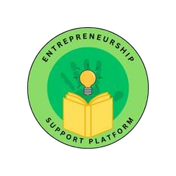

:

Adjournment

The meeting was closed at exactly 10:45.

Approval

**Minutes approved by:**

Sibusisiwe Kunene

25 April 2024